CG LAB-EXP 5

Name- Aditya Ramakrishnan

PRN NO-119A1004

SE/C1

Aim- To study 2D Transformations

Code:

#include<graphics.h>

#include<stdio.h>

#include<conio.h>

void main()

{

int gd = DETECT, gm;

int x1, y1, x2, y2, x3, y3, tx, ty, sx, sy, shx, shy, ch, ch1;

clrscr();

initgraph(&gd,&gm,”C:\\TURBOC3\\BGI”);

printf(“\nEnter (x1, y1)”);

scanf(“%d%d”,&x1,&y1);

printf(“\nEnter (x2,y2)”);

scanf(“%d%d”,&x2,&y2);

printf(“\nEnter (x3,y3)”);

scanf(“%d%d”,&x3,&y3);

while(1)

{

printf(“\n1.Translation \n2.Scaling \n3.Shearing \n4.Reflection at X \n5. Reflection at Y \n6.Quit”);

printf(“\nEnter your choice”);

scanf(“%d”,&ch);

clrscr();

switch(ch)

{

case 1:

{

printf(“\nEnter tx and ty”);

scanf(“%d%d”,&tx,&ty);

line(x1,y1,x2,y2);

line(x2,y2,x3,y3);

line(x3,y3,x1,y1);

line(x1+tx,y1+ty,x2+tx,y2+ty);

line(x2+tx,y2+ty,x3+tx,y3+ty);

line(x3+tx,y3+ty,x1+tx,y1+ty);

break;

}

case 2:

{

printf(“\nEnter sx and sy”);

scanf(“%d%d”,&sx,&sy);

line(x1,y1,x2,y2);

line(x2,y2,x3,y3);

line(x3,y3,x1,y1);

line(x1\*sx,y1\*sy,x2\*sx,y2\*sy);

line(x2\*sx,y2\*sy,x3\*sx,y3\*sy);

line(x3\*sx,y3\*sy,x1\*sx,y1\*sy);

break;

}

case 3:

{

printf(“\n Choose: “);

printf(“\n1. Shearing in X \n2. Shearing in Y”);

scanf(“%d”,&ch1);

if(ch1==1)

{

printf(“\nEnter shx”);

scanf(“%d”,&shx);

line(x1,y1,x2,y2);

line(x2,y2,x3,y3);

line(x3,y3,x1,y1);

line(x1+y1\*shx,y1,x2+y2\*shx,y2);

line(x2+y2\*shx,y2,x3+y3\*shx,y3);

line(x3+y3\*shx,y3,x1+y1\*shx,y1);

break;

}

else if(ch1==2)

{

printf(“\nEnter shy”);

scanf(“%d”,&shy);

line(x1,y1,x2,y2);

line(x2,y2,x3,y3);

line(x3,y3,x1,y1);

line(x1,y1+x1\*shy,x2,y2+x2\*shy);

line(x2,y2+x2\*shy,x3,y3+x3\*shy);

line(x3,y3+x3\*shy,x1,y1+x1\*shy);

break;

}

else

{

printf(“Wrong choice”);

break;

}

case 4:

{

line(x1,y1,x2,y2);

line(x2,y2,x3,y3);

line(x3,y3,x1,y1);

line(x1,((240-y1)+240),x2, ((240-y2)+240));

line(x2, ((240-y2)+240),x3, ((240-y3)+240));

line(x3, ((240-y3)+240),x1, ((240-y1)+240));

break;

}

case 5:

{

line(x1,y1,x2,y2);

line(x2,y2,x3,y3);

line(x3,y3,x1,y1);

line(((320+x1)+320),y1, ((320+x2)+320),y2);

line(((320+x2)+320),y2, ((320+x3)+320),y3);

line(((320+x3)+320),y3, ((320+x1)+320),y1);

break;

}

case 6:

{

exit(0);

}

default:

printf(“Wrong Choice”);

}

getch ();

closegraph();

}

}

}

Output:

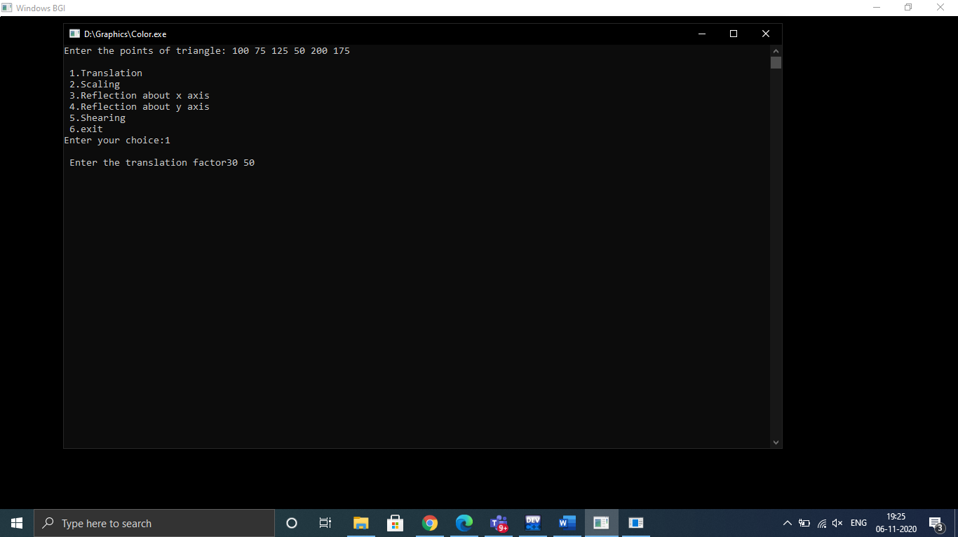

Translation:

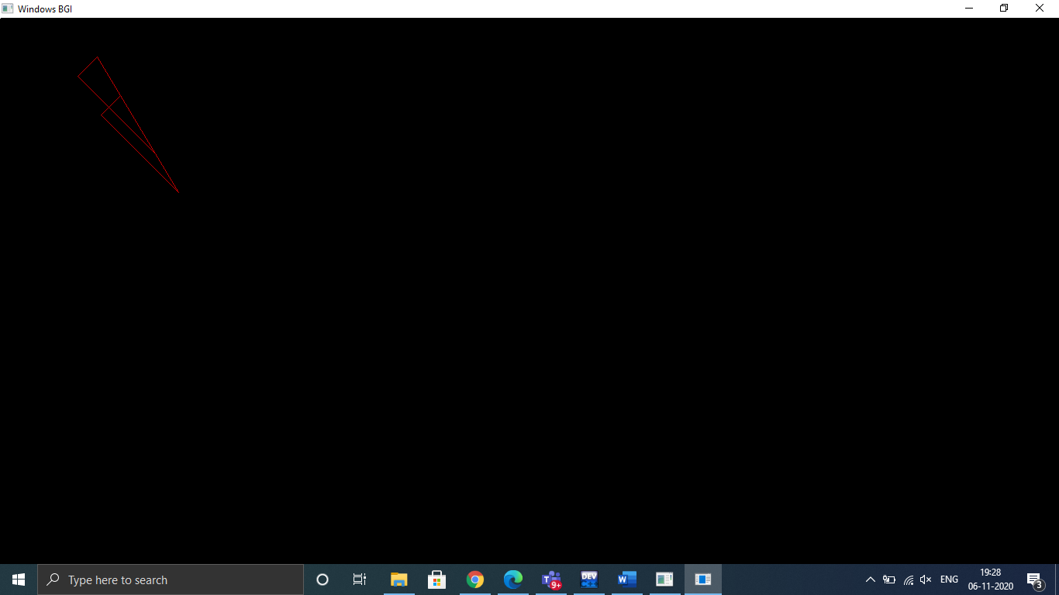

Scaling:

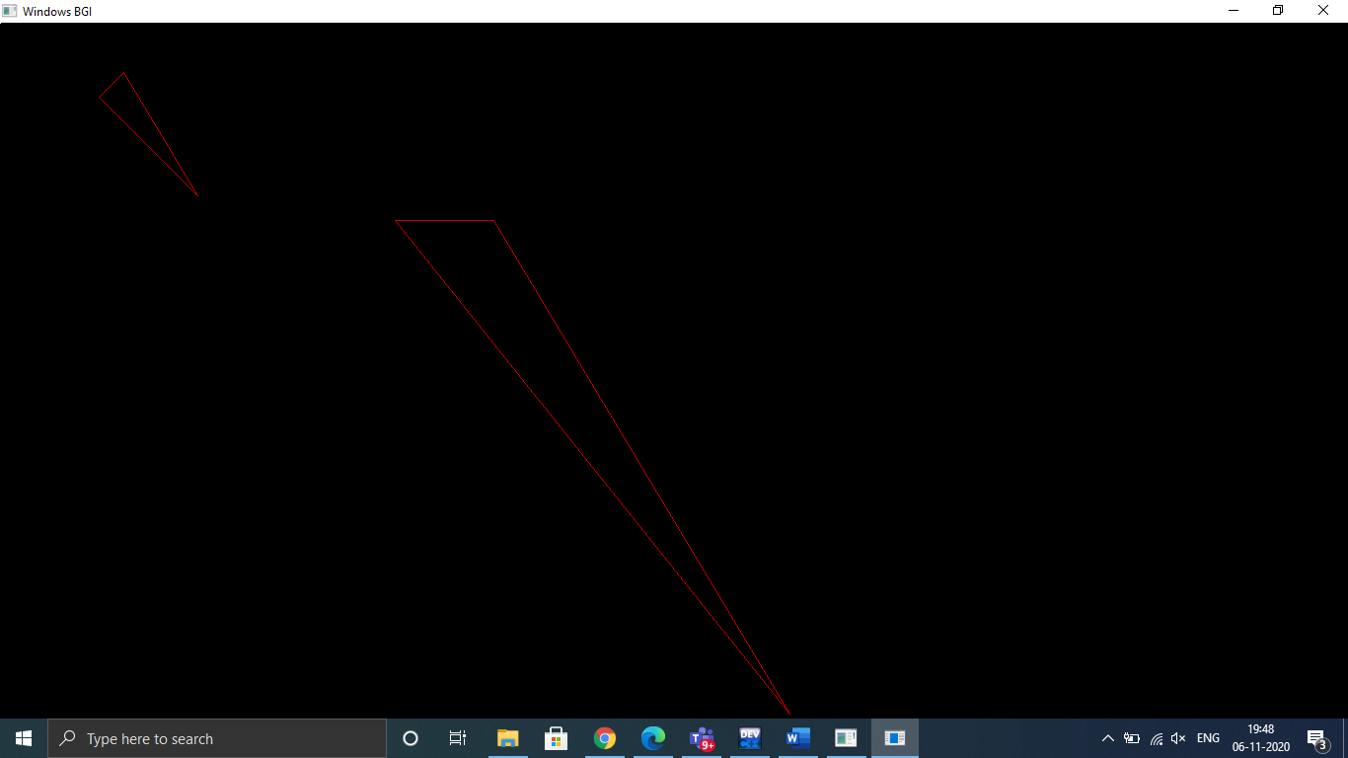

Shearing at X:

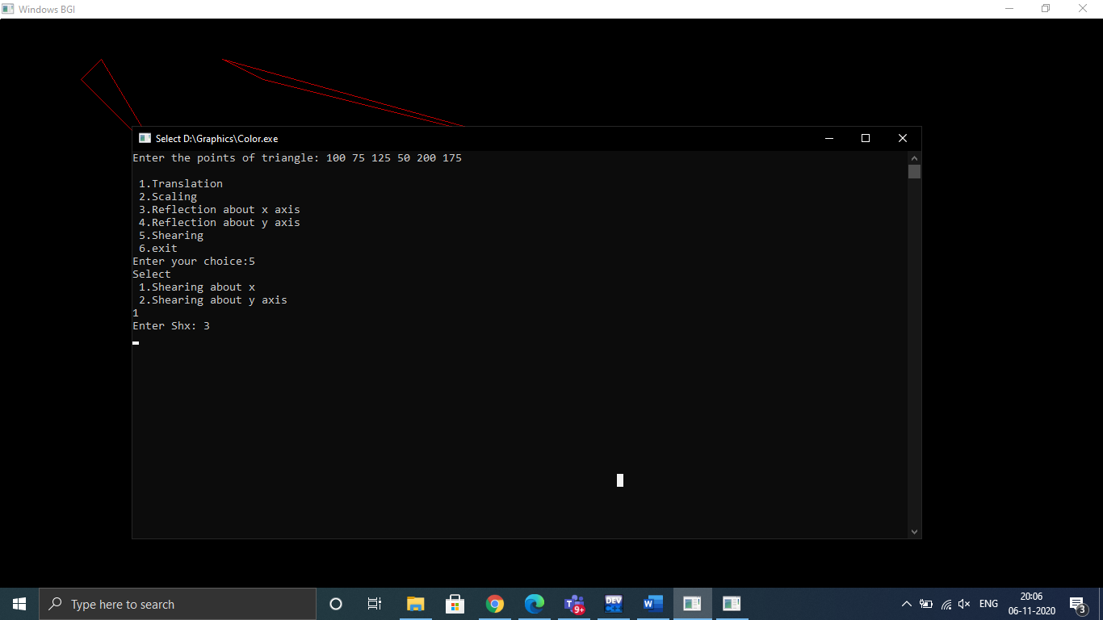

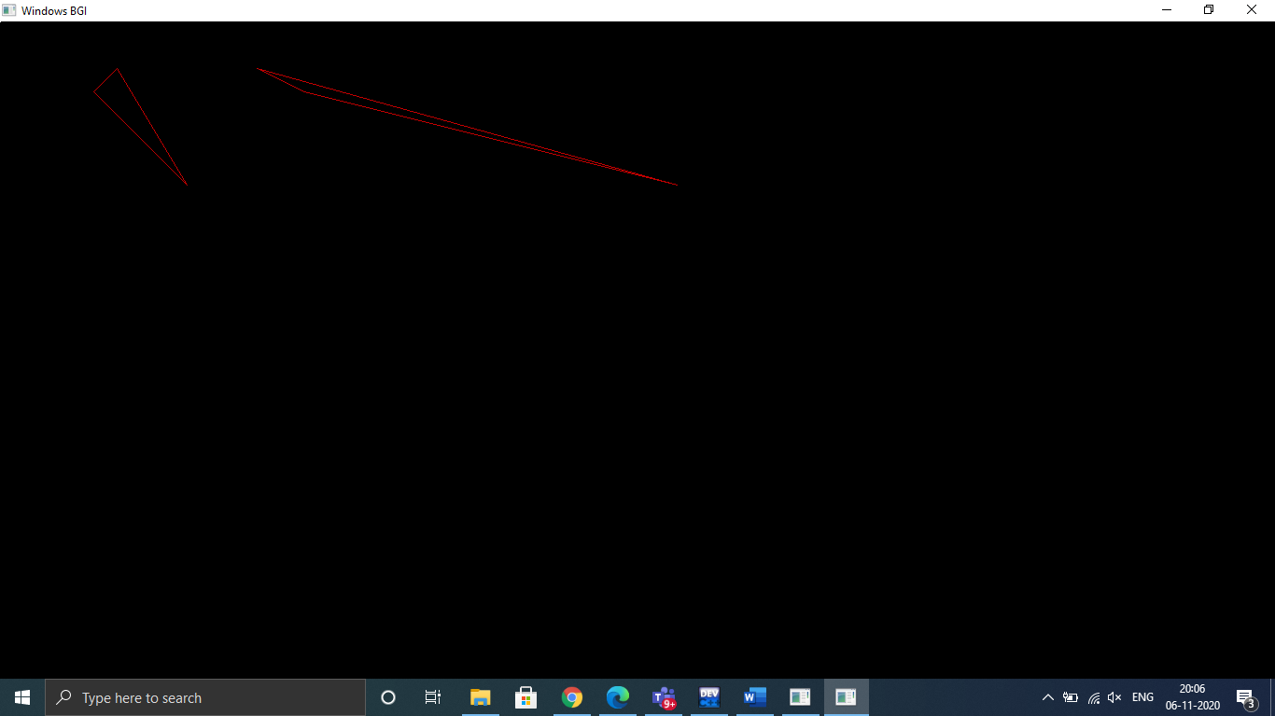

Shearing at Y:

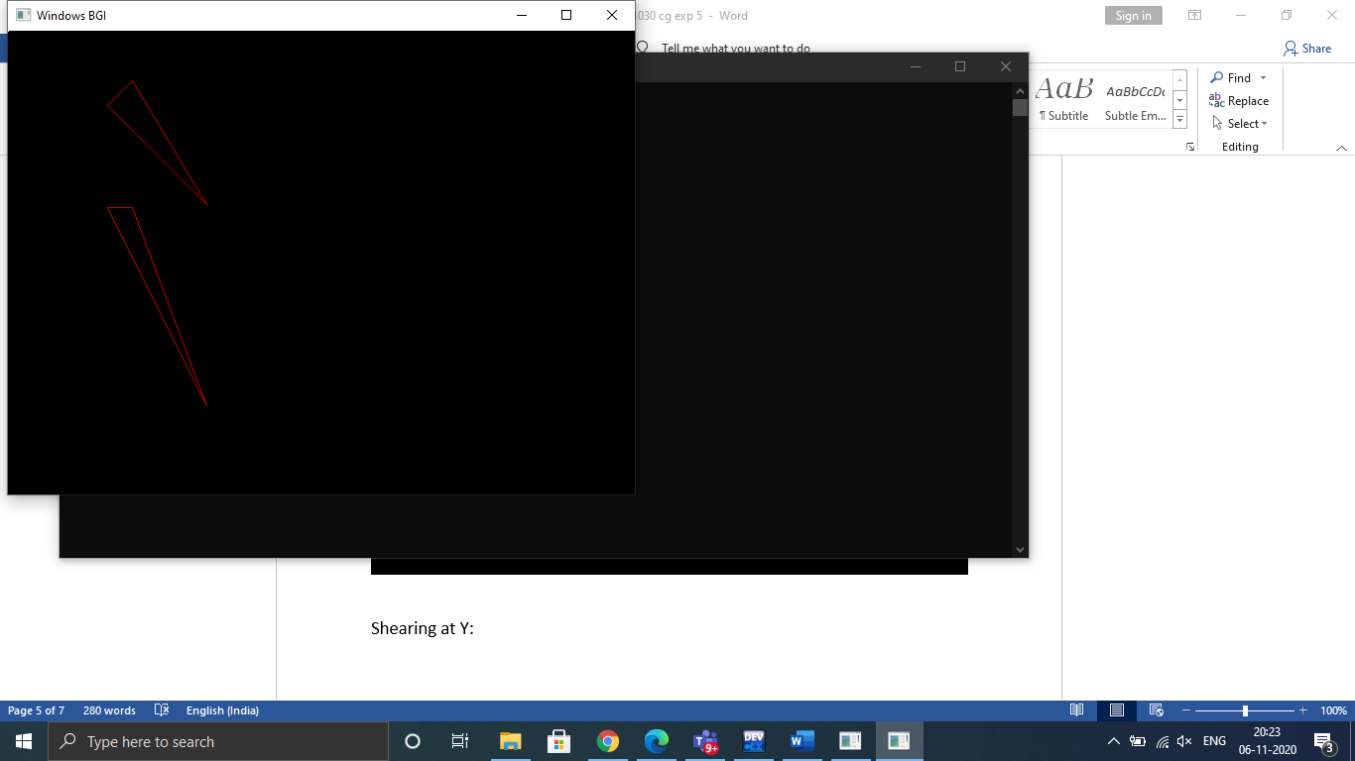

Reflection about X axis:

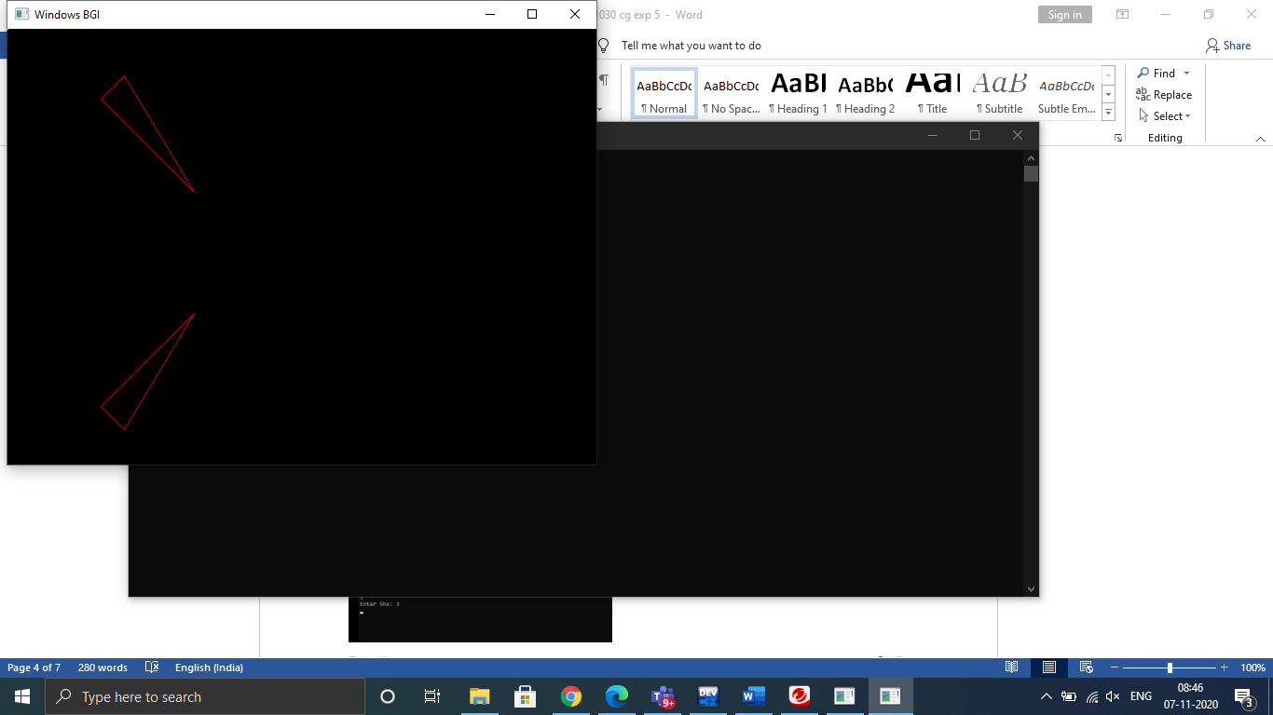

Reflection about Y axis:

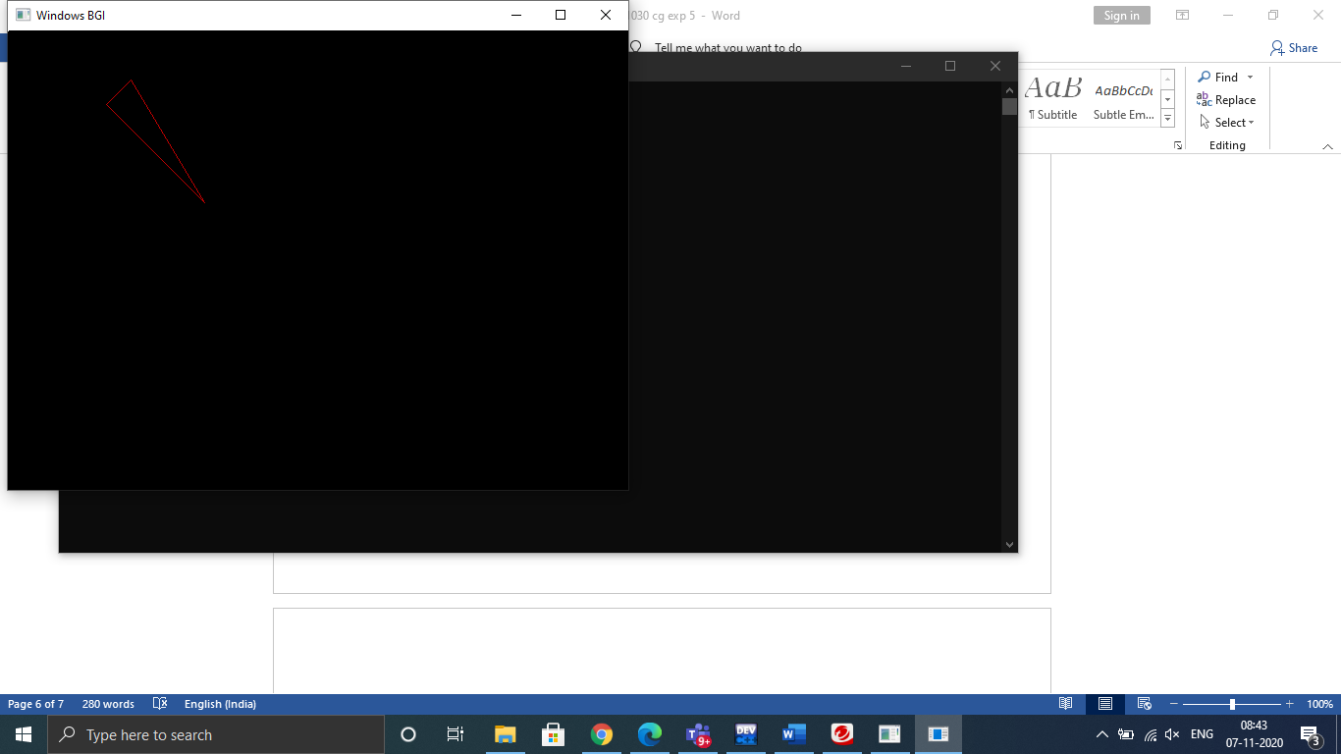

Conclusion:

Hence, we have studied all the different types of transformations ie: Translation, Scaling, Shearing, Reflection at X and Reflection at Y.

Limitations:

1. The figures can sometimes go out of the display screen.
2. For Reflection, the output is mathematically not accurate, since we are assuming the X axis and Y axis to be the centre of the screen, instead of X=0, Y=0 lines.